Multi-lingual international healthcare professional
Medical devices and pharmaceutical
With extensive experience in clinical trials, management, sales/marketing
A profound clinical background in cardiovascular, oncology and CNS
A deep understanding of diagnostic imaging technologies and general healthcare related issues (reimbursement, regulatory affairs)
on a European level and strong customer focus

Personal Details
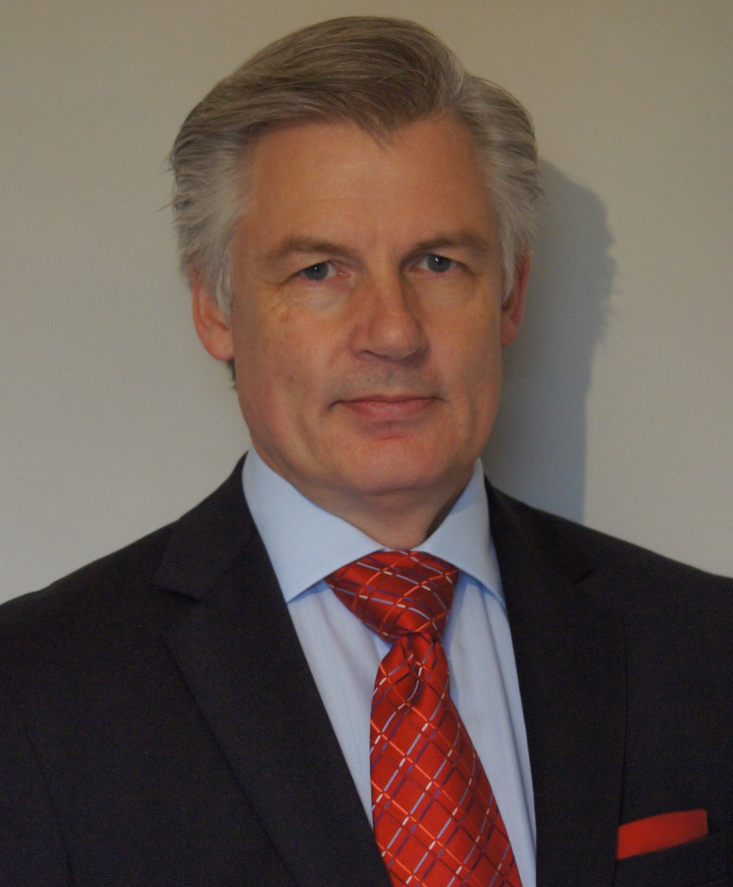
Name & nationality : Jan REIJNEN - Dutch
Address : langveldweg 34
City : 3910 Neerpelt - Limburg
Country : Belgium
Mobile number : +32 (0)4.76.06.91.95
Email : j.reijnen@imcc-medical.be
Website : www.imcc-medical.be
Date of birth : 07/11/1957

Professional experience

Keywords excellent leadership, rigorous, accurate and solution oriented
People minded team player
Passionate healthcare professional

July 2010 – present NEXSTIM Company – Finland
Sales manager and business developer, major European countries, MEA - In neurosciences and neurosurgery.
- Introduce a new technology (NBS) in neurosurgery, neurophysiology and stroke therapy.

2000 – June 2010 HITACHI MEDICAL SYSTEMS EUROPE

2008 – June 2010 European marketing/product manager MRI and CT, home based Belgium
- Implement market studies for the preparation/launch of new products.
- Develop relevant marketing materials for internal/external communication.
- Prepare and provide product training in co-operation with HMC.
- Product regulatory affairs
- Representant for the company in the COCIR organization.

2003 – 2008 Manager Export division, home based Belgium
European Product manager cardiology
Region: 26 countries, Scandinavia, Baltic countries, whole formal eastern block countries, Russia and southern Europe
- Developing new business in urology / oncology / surgery and driving Elastrography clinical trial: monitoring/ project management.
- Driving business through a distributor network and KOL’s with a turn over of 7.5M€ in ultrasound and 15M€ in MRI/CT
- Steering a team of application specialists and sales responsible
- Full P&L budget responsibility.

2000 – 2003 Sales manager Export division, home based Belgium
Region: 26 countries, Scandinavia, Baltic countries, whole formal eastern block countries, Russia, CIS and southern Europe
- Building up a distributor structure and driving sales in ultrasound
- Growing business from 1.5 to 6M€
- Provide onsite sales and application training.
- Create a network of KOL’s
- Shared P&L budget responsibility.
1998 – 2000 NYCOMED AMMERSHAM, OSLO, home based Belgium
Research application manager
- Responsible for clinical research sites and quality assessment in USA and Western Europe in the “NC 100/100”, phase II, III and IV studies.
- Running pilots studies echo-genic brachytherapy seed project in prostate cancer in the USA and Western Europe.
- Keep track of KOL’s need and inputs to assure technology progress related to the studies.
- Interface between Nycomed Ammersham and global leading hardware manufacturers in ultrasound.

1997 – 1998 General teaching hospital: ZOL (Ziekenhuis Oost Limburg)
Echocardiographist / study nurse
- Building up a cardiovascular ultrasound laboratory and introducing Stress Echocardiography

1995 – 1997 HEWLET PACKARD, Brussels-Belgium
Sales and applications engineer, region Flanders
- Cardiovascular/anaesthesiology ultrasound and ECG systems

1990 – 1995 HEWLET PACKARD, European marketing department, Böblingen- Germany
Product development engineer and key opinion leader manager
- International trainings and product/application specialist cardiovascular ultrasound
- New product introduction, product launch and training
- Training Specialist.

1983 – 1990 Echocardiographist – St Elisabeth Hospital Arnhem- Netherlands
- Full responsibility in the daily running of echocardiography lab, introducing new technologies such as CW Doppler and Color Doppler.
- Primary diagnostic responsibility in congenital and general heart diseases, reporting to 7 cardiologists
Honoris Causa Sports instructor cardiac revalidation.
- Cardiac revalidation sports instructor leading a group of 130 ex cardiac patients.

1980 – 1983 Graduated cardiac intensive care nursing – Diaconessen Ziekenhuis Arnhem- Netherlands

1976 – 1980 General nurse – Gemeente Ziekenhuis Arnhem – Netherlands

Relevant Education and Training

Job related: Several training in marketing, (change) management, communication and sales
1983 autodidact and hospital experience in cardiovascular ultrasound
1981 graduated: specialised cardiac intensive care nurse
1979 graduated: general nurse

Personal skills and competences

Languages Dutch (mother tong), English (fluent), German (fluent), French (fluent)
IT clinical tools TRACE (v.1.0) (TRAcking of Clinical Equipment) and ec1 (v.3.0e) clinical trials management software, Clinphone, eCRF informTM 4.6
Personal competences excellent leadership, motivation/presentation skills, out of the box thinking, flexible and stress resistant

Interest

Reading, sailing, running, motorcycling, cooking, enjoying life.

