Senior Clinical Research Associate / Medical Engineer
Medical devices & pharmaceutical

Personal Details
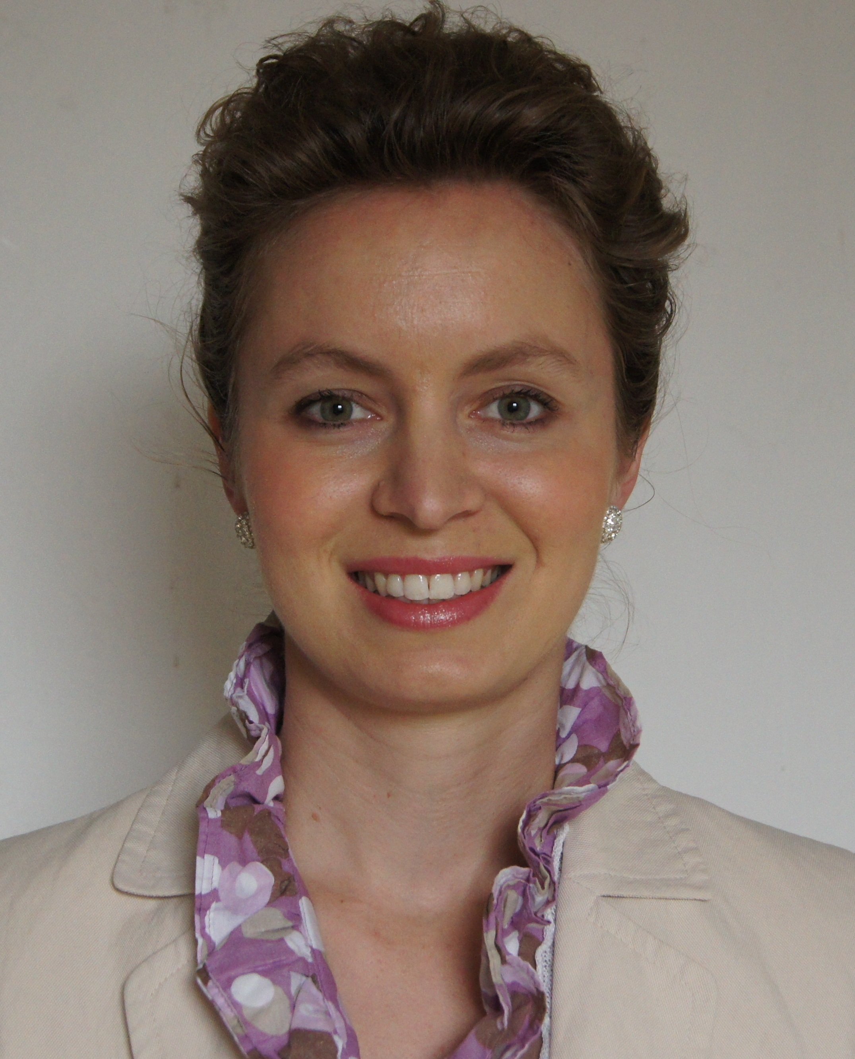
Name : Ludivine CANTIN - French
Address : Langveldweg 34
City : 3910 Neerpelt - Limburg
Country : Belgium
Mobile number : +32 (0)493.25.43.03
Email : l.cantin@imcc-medical.be
Website : www.imcc-medical.be
Date of birth : 28/07/1982

Professional experience

Keywords Research oriented, medical devices and pharmaceutical
Rigorous, accurate and solution oriented

April 2009-present STICARES InterACT – the Netherlands
Senior Clinical Research Associate / Regulatory Affairs Specialist
Area of expertise: cardiovascular
Region: Belgium, Netherlands, France
- medical device trial (drug eluting stent trial) 240 patients randomized Phase II and III.
- Drug trial 1 (15000 patients) and drug trial 2 (20000 patients)- Studies: cardiology drug trials. Responsible of 85 active patients (10 sites) for both studies. Phase III and IV.
- Initial submission to EC
- Substantial / non substantial amendments
- End of trial notification
- eCRF informTM 4.6, ec1 (v.3.0e), TRACE (v.1.0), Clinphone, SETHI
- Business development, France-Belgium, (creation of feasibility questionnaire)
- Setting up study centers
- Initiation and close-out visits of study sites on completion of the trial
- Qualification and motivation visits
- Monitoring the trial throughout its duration
- Briefing doctors and nurses on the conducting of the trial
- Filling and collation of trial documentation and reports

January 2006-March 2009 HITACHI MEDICAL SYSTEMS – Zug Switzerland
July 2007-March 2009 International Clinical Specialist (Export Division), France, Home based
Area of expertise: Cardiology, Vascular, Radiology, Urology, Gynaecology, Obstetrics
Region: Scandinavia, Baltic countries, Eastern countries, Balkans, Cyprus
- Clinical Cancer imaging research (Medical device): Worldwide multi-centric study on Elastrography. Main area of clinical study: radiology oncology (breast, liver, prostate), female pelvic floor. Phase II, III.
- Setting up study centers: 10
- Monitoring the trials on the 10 sites with responsibility 50 active patients
- Medical advanced technologies presentations.
- Working on clinical support by providing expert advice and
through effective demonstrations.
- Training of doctors/study team on the medical system.
- Realization of newsletter.

March 2007-July 2007 Application Specialist in MRI
Area of expertise: Radiology, Musculoskeletal
- Application for customer support.
January 2006-March 2007 Application Specialist in Cardiac and Vascular Ultrasound
Area of expertise: Cardiology, vascular
- Working on clinical support to potential and existing customers by providing expert advice and through effective demonstrations and installations.
- Supporting the entire sales process.

Jan 2005- September 2005 Cardiovascular and Renal Stenosis MR Applications Research Engineer, Ninewells Hospital, Dundee, Scotland
Area of expertise: Radiology, cardiology
Region: Scotland, UK
- software evaluation study for MRI applications, more than 100 patients data, phase II.
- Optimization of clinical MRI reporting, cardiac and kidney MRI
- Ensuring safety of patient and staff in MRI department

March 2004- September 2004 MRI Department Research Engineer, University Hospital of Caen, Caen, France
Area of expertise: Neurology
Region: Normandie, France
- Spectroscopic analysis of brain tumor / brain tumor study, MRI spectroscopy
- Working on more than 50 patients, phase I and II.

Relevant Education and Training

July 2010 TRACE (v.1.0) (TRAcking of Clinical Equipment) and ec1 (v.3.0e) clinical trials management software, Business object Inform, and eRoom training
Clinphone training
May 2010 Effective site management: communication/motivation/negotiation and management
April 2009 eCRF informTM 4.6 training
April 2009 GCP-ICH training
December 2008 How to manage and build efficient international sales networks
2004 Completion of Erasmus Course in MRI, Rennes, France, GCP-ICH training

2000 - 2005 Master’s Degree in Physics, Engineering Graduate School: Ecole Nationale Supérieure d’Ingénieurs de Caen, France

Personal skills and competences

Languages French (mother tong)
English (fluent)
Dutch (good)

IT clinical tools eCRF informTM 4.6, ec1 (v.3.0e), TRACE (v.1.0), Clinphone, SETHI

Personal competences take initiative, motivated, tenacious and eager to learn

Interest

Music First violinist in Orchestra, Graduated from the Rennes conservatory (Bretagne-France)
Piano, autodidact
Leisure Sailing, sports, reading

